Lab – Module 1

Shaun Pritchard

Rasmussen College

CDA3315C

Alan Dennis

July,12 2020

Lab – Module 1

1. **Logged in to student cloud portal system.**

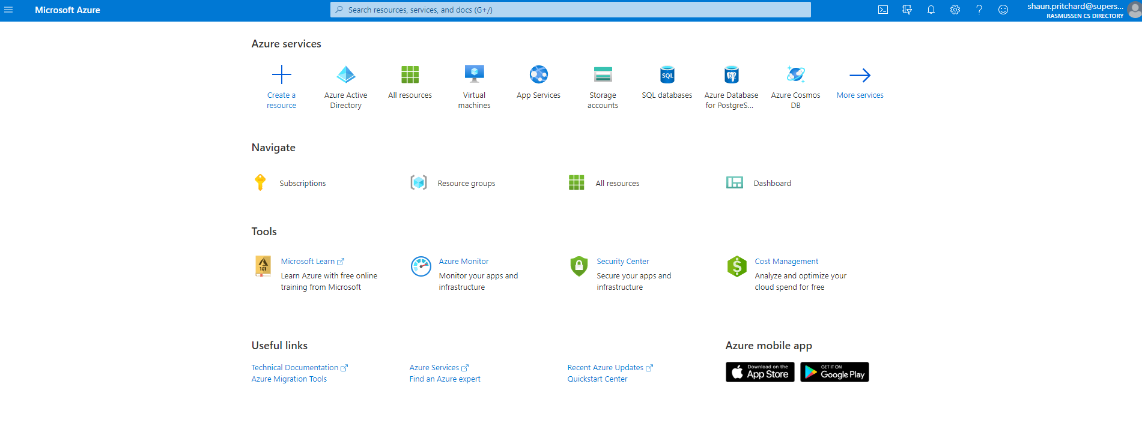

1. **Created a new Web App + MySQL service on Azure.**

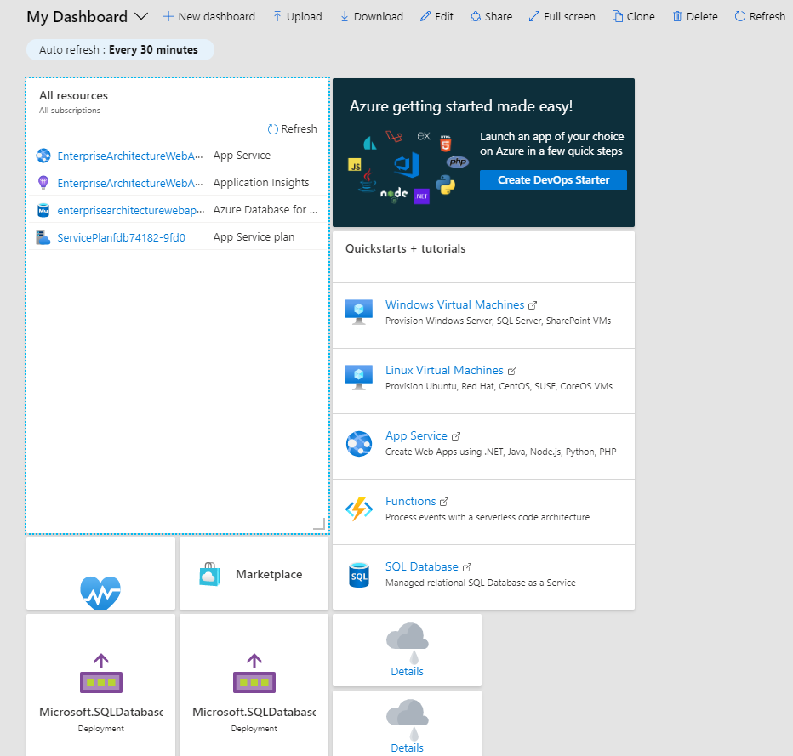

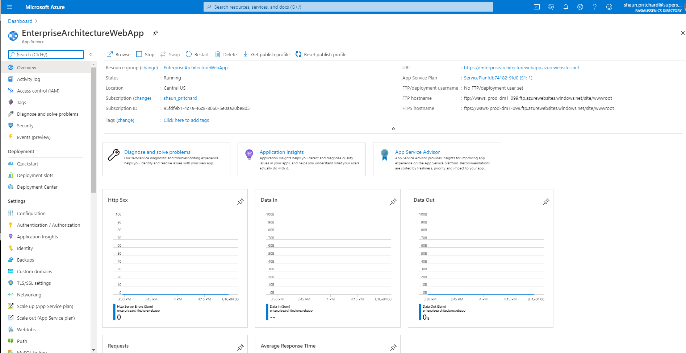

1. **Create a new MySQL database service.**

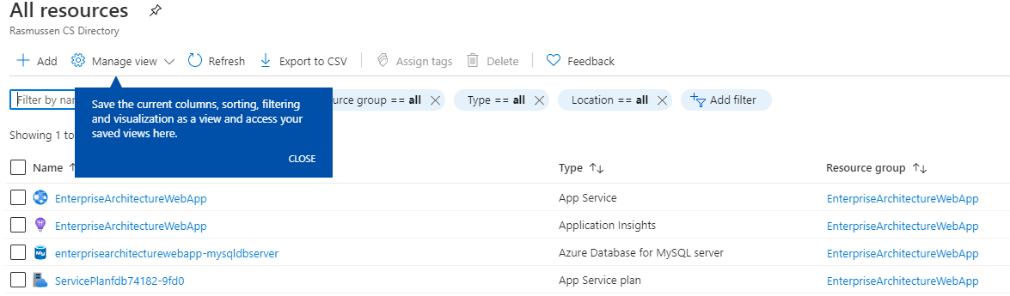

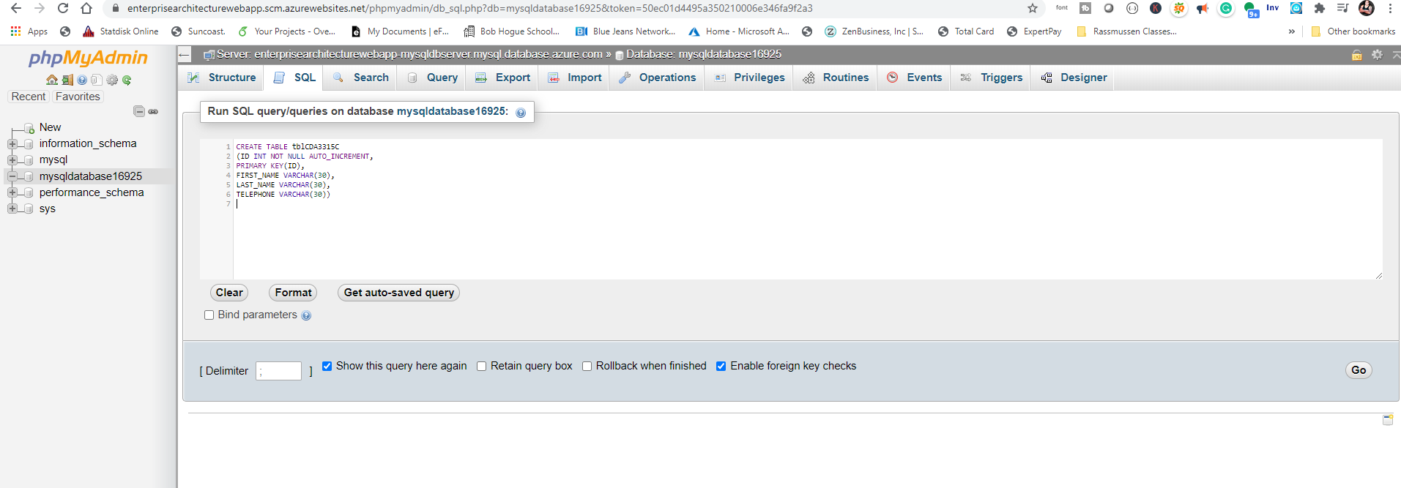

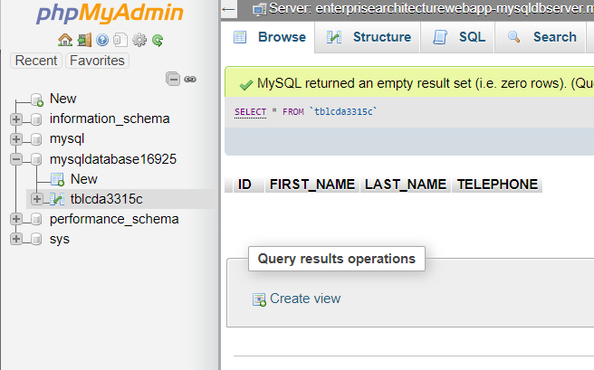

1. **Create a new Web App service connection string.**

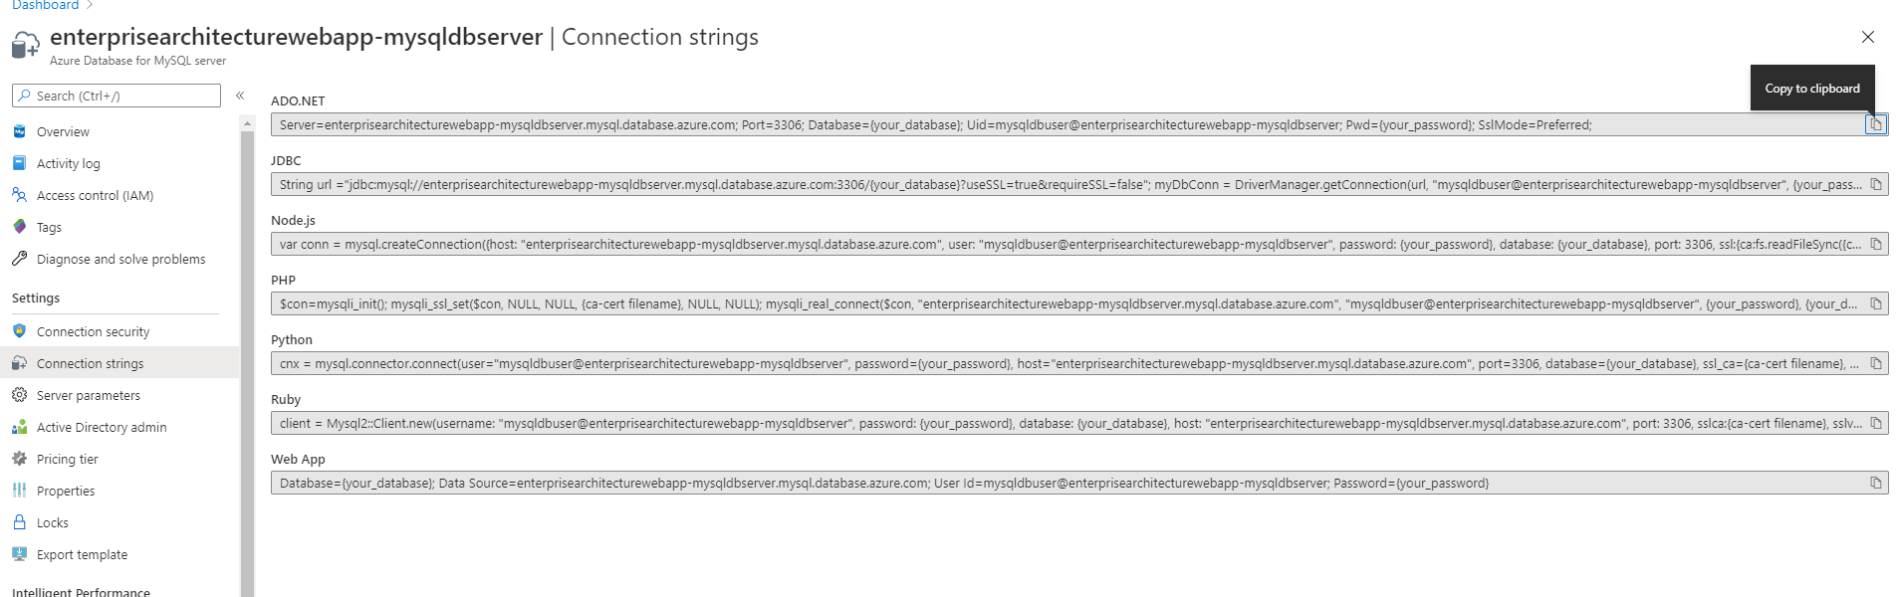

1. **Create a new Web App service phpMyAdmin extension.**

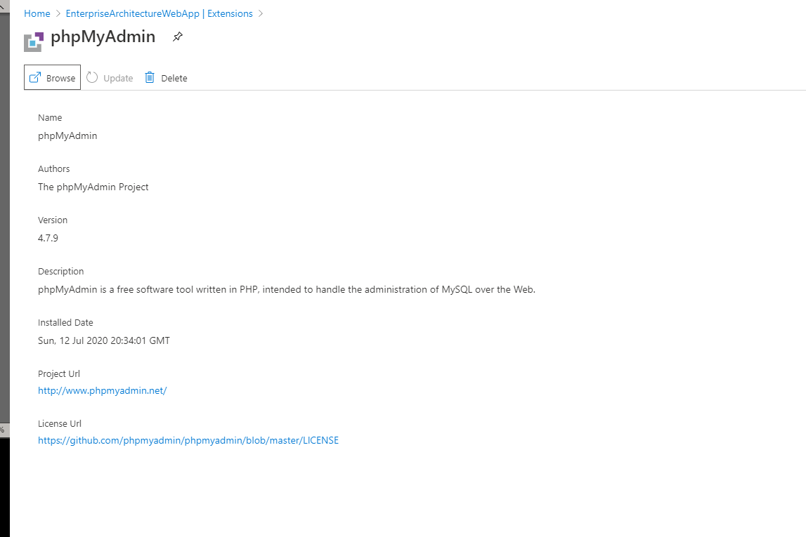

1. **Created PHP service and launched PHP my Admin**

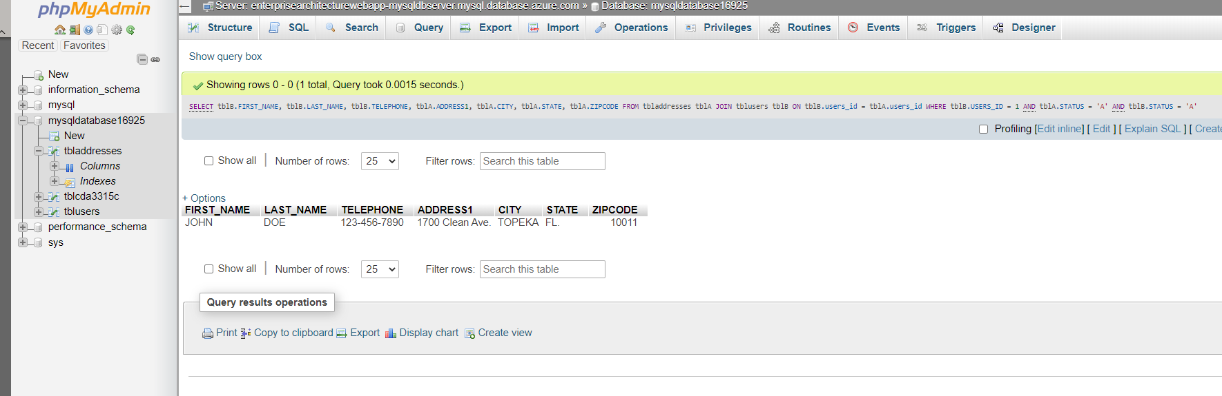

1. **Create Index.php frontend**

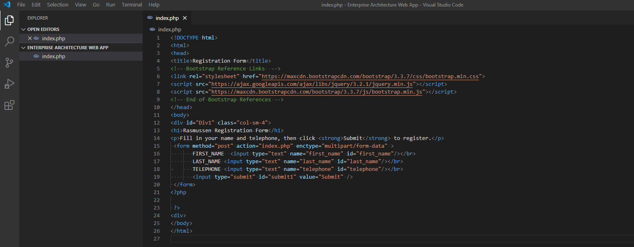

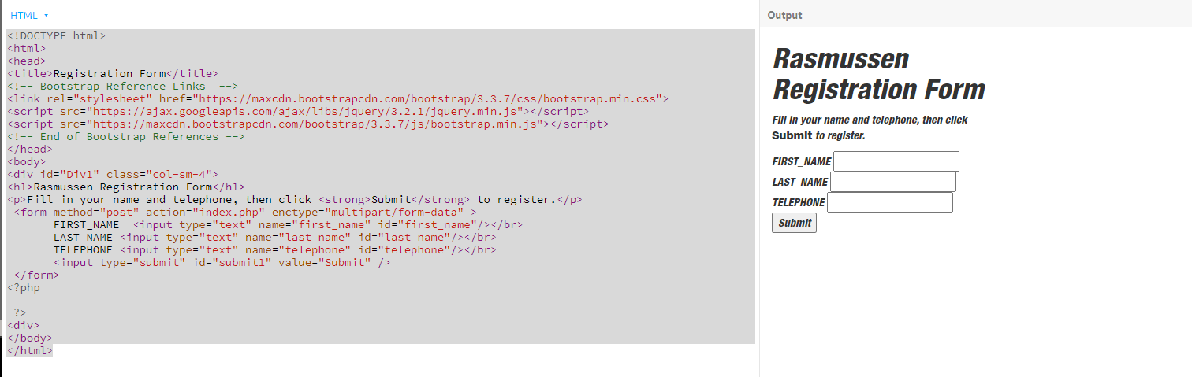

1. **Login to the new phpMyAdmin web app.**

**I had some issues with the inline CSS, so I had to repair it to the best of my knowledge using bootstrap and raw CSS It is responsive now see below.**

**Issues from CSS:**

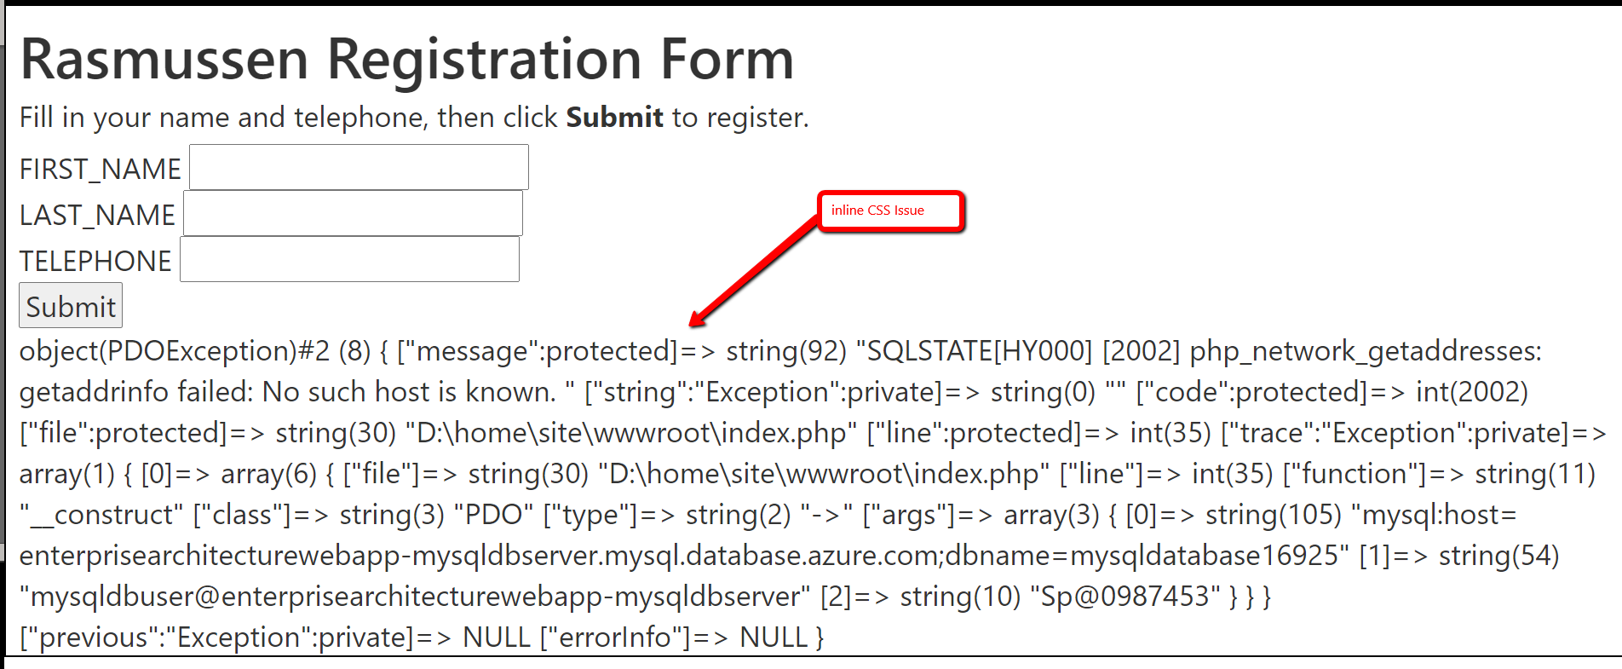

1. **Using FTP to load finished Web App:**

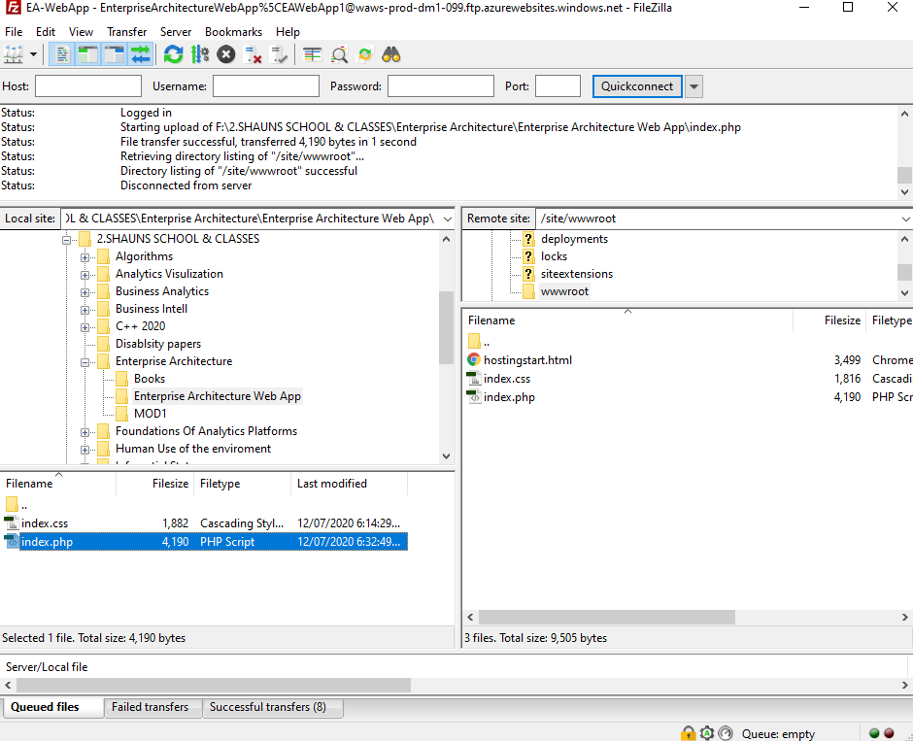

**10.Finished responsive Web App with 6 submit to DB styled by me:**

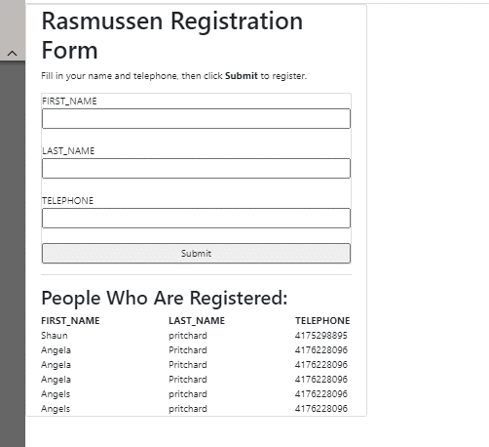

1. **Responsive version**

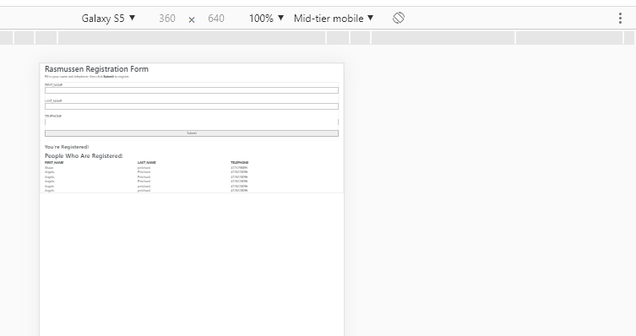

1. Here is with the original inline CSS style. It did not seem to scale correctly.

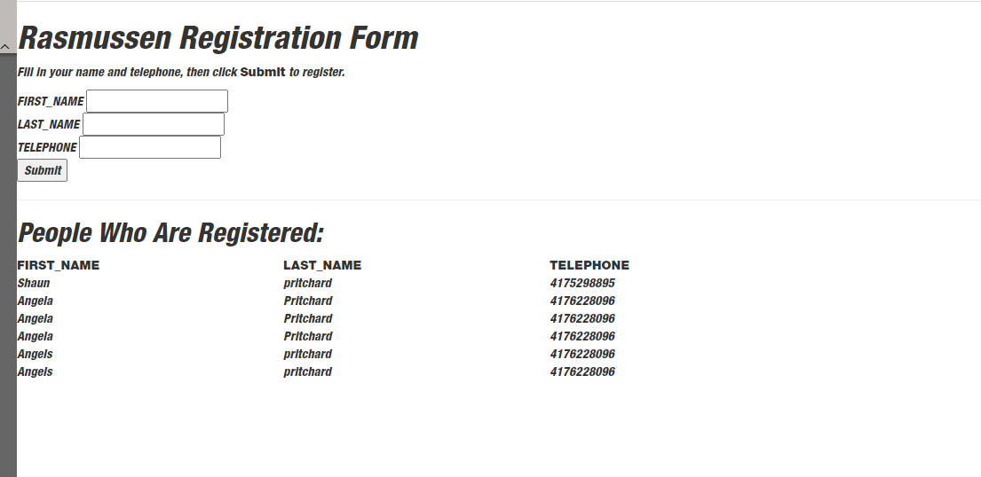

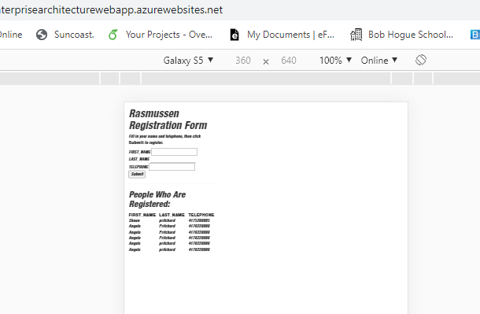

**Finished…**